
A Day In The Life Of A Discovery Child In Year 1 and 2
The academy day starts with an early morning task. This task enables the children to practice many of the things they have learnt that week in maths, topic and reading. An example of this is below.
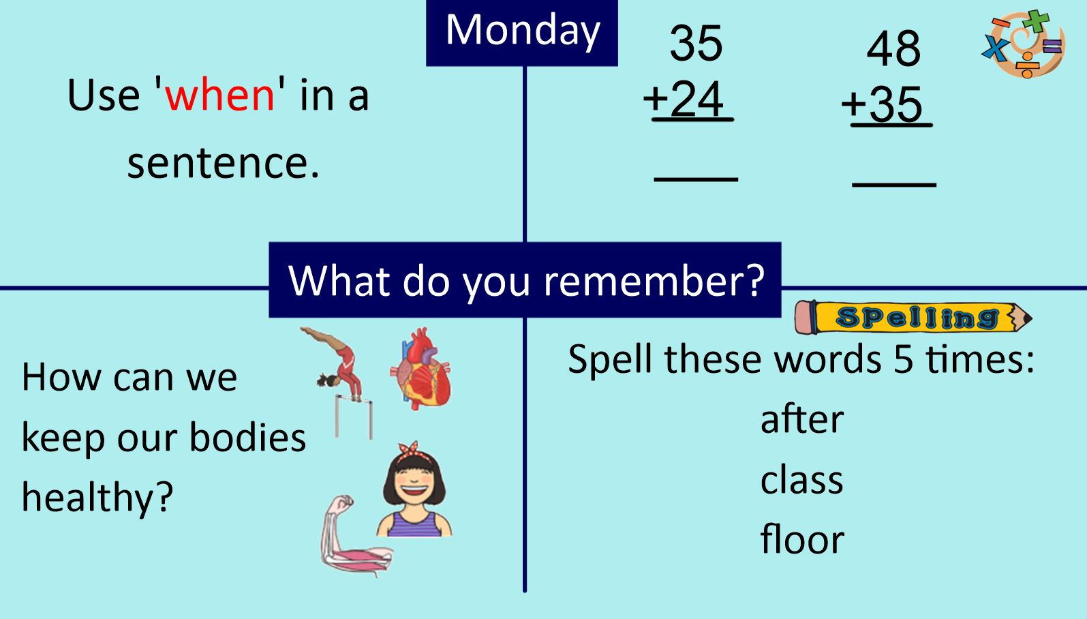Following on from this the children will be in a maths lesson or a writing lesson. If it is a maths lesson the children will be taught a lesson from Maths No Problem. This will involve practical activities to support the children with their understanding of a maths topic. For example, division. The lesson will be part of a series of lessons on division. If it is a writing lesson the children will be building on a piece of writing that the children have been working on over the week. This may be to write a letter about the Toy Day they recently experienced. In this lesson they will be learning about how to spell different words and how to use the correct punctuation such as full stops and capital letters.
The children will then have break time which will be followed by an hour of reading. This will include reading, understanding, and answering questions about a book. This will then be followed by a twenty-minute maths mastery lesson.
The children will then have their lunch and a play time. Following this they will continue with their current topic. This may be a science block of work which helps the children to understand and learn about Everyday Materials or a history unit in which the children put their historical skills into practice whilst learning about Grace Darling. Each block of work will last for 5 or 6 lessons. Each one of them building on the knowledge and skills from the one before.
The children will then go out to play returning to the classroom to finish with handwriting practice and a story.
All of this before they put on their coats ready for home time.
As you can see every day is very busy. The learning and experiences the children have are built upon the learning from the day before. If a child misses a day or more then you can see they will miss aspects of their learning which they not meet again until the next year. For example, if a child misses the work in maths on 2D and 3D shape they will not return to it until the following year. That leaves them with a gap in their learning before they even start the next year.
Please, please therefore ensure your child is in the academy and not absent. As you know we can help you with improving attendance by giving your child medicine during the day. We will also always ring you if we feel that they are not well enough to be here.

