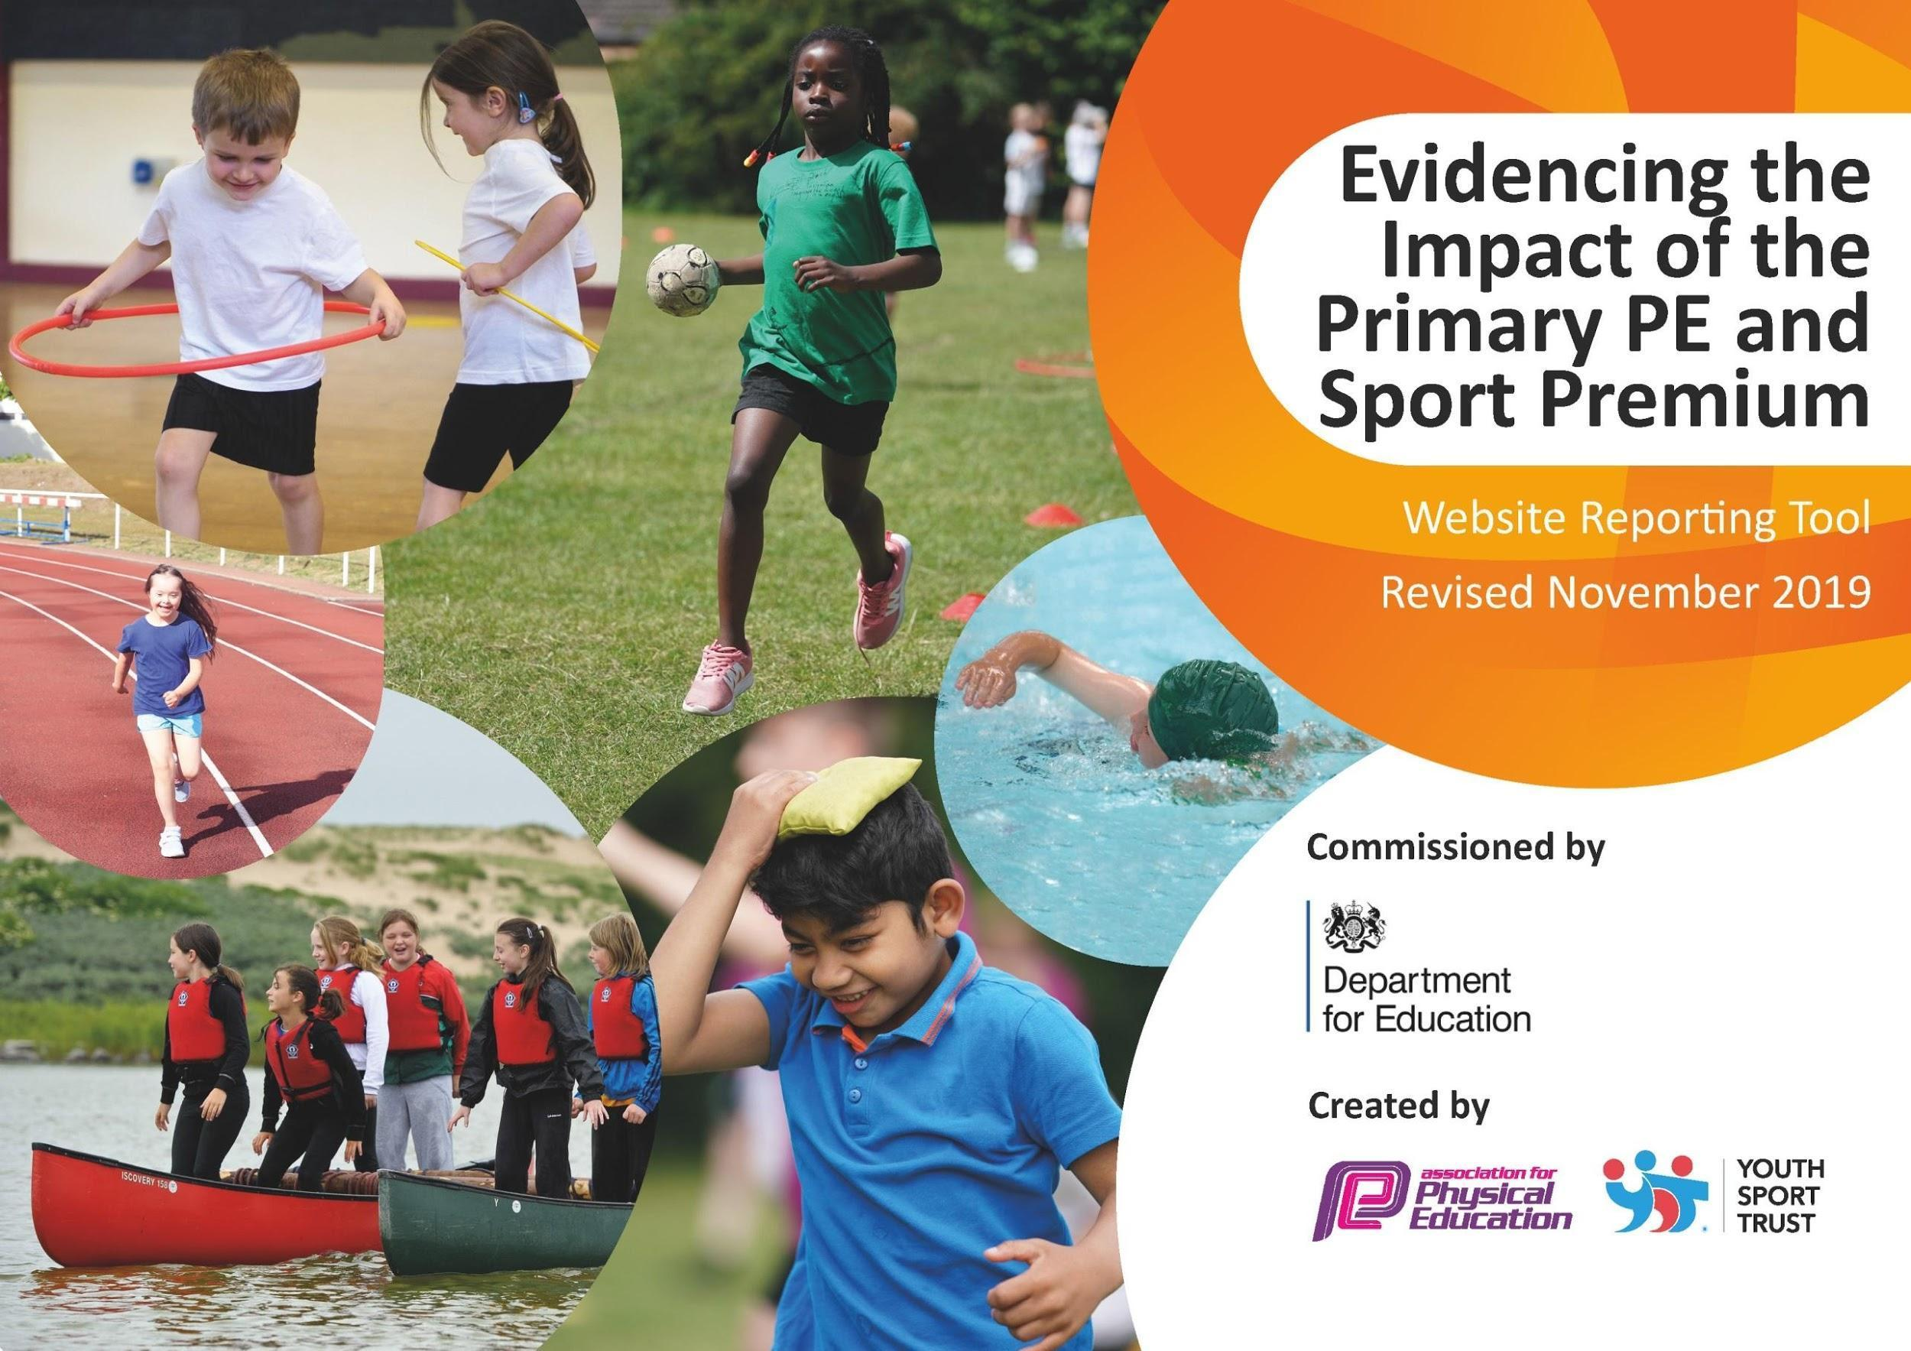
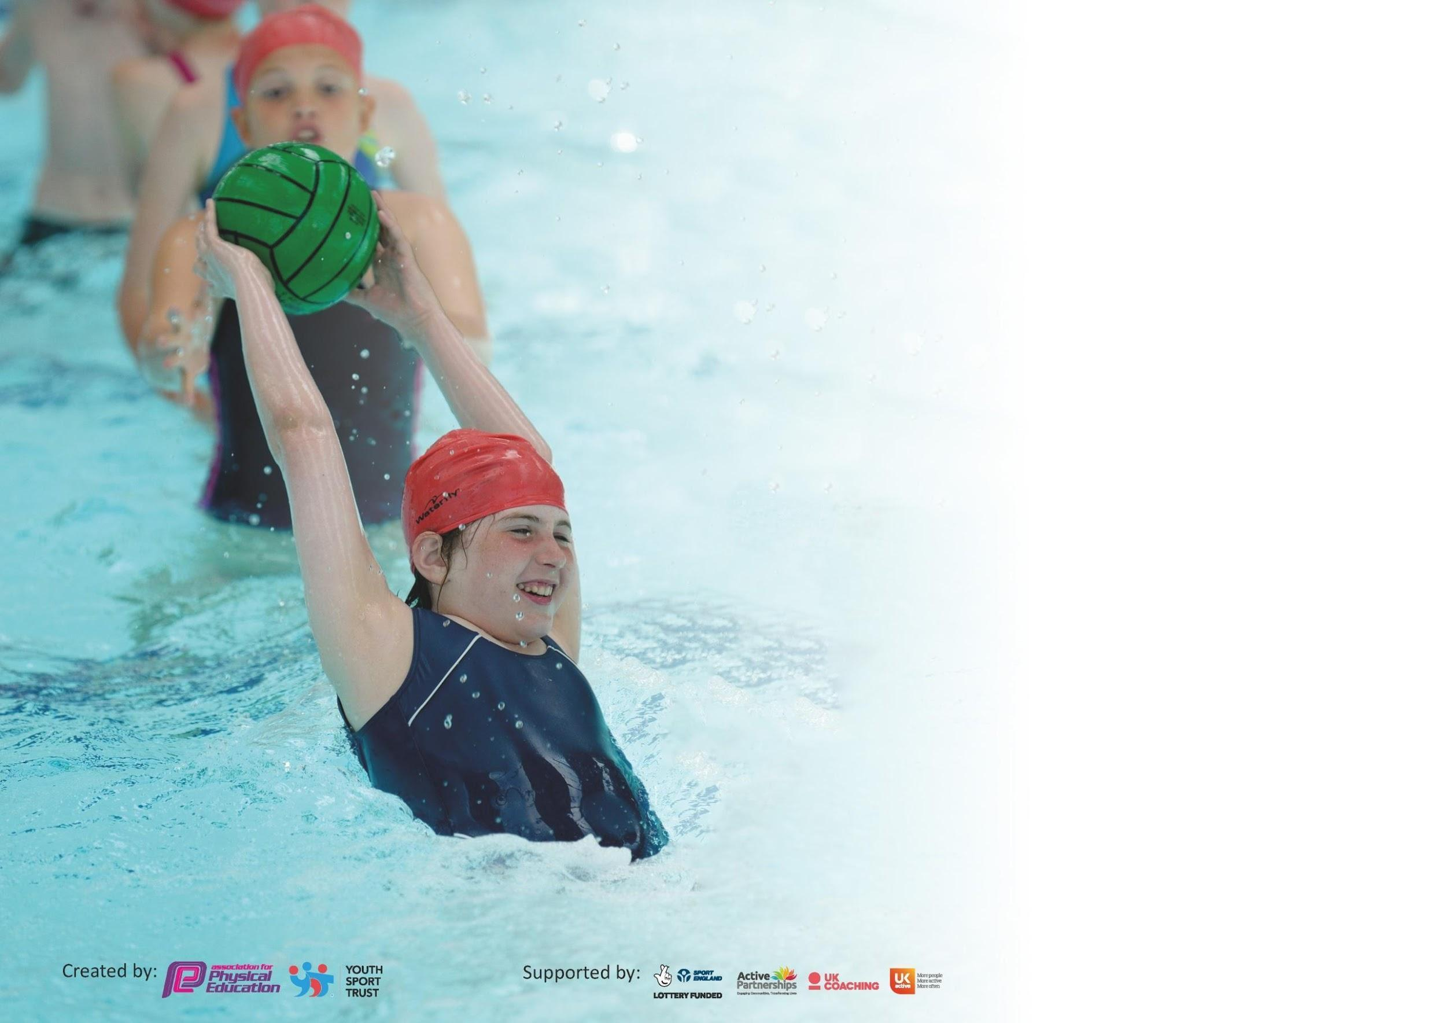

It is important that your grant is used effectively and based on school need. The Education Inspection Framework (Ofsted 2019 p64) makes clear there will be a focus on ‘whether leaders and those responsible for governors all understand their respective roles and perform these in a way that enhances the effectiveness of the school’.

Under the Quality of Education criteria (p41) inspectors consider the extent to which schools can articulate their curriculum (INTENT), construct their curriculum (IMPLEMENTATION) and demonstrate the outcomes which result (IMPACT).

To assist schools with common transferable language this template has been developed to utilise the same three headings which should make your plans easily transferable between working documents.

Schools must use the funding to make additional and sustainable improvements to the quality of Physical Education, School Sport and Physical Activity (PESSPA) they offer. This means that you should
use the Primary PE and Sport Premium to:

- Develop or add to the PESSPA activities that your school already offer
- Build capacity and capability within the school to ensure that improvements made now will benefit pupils joining the school in future years

Please visit gov.uk for the revised DfE guidance including the 5 key indicators across which schools should demonstrate an improvement. This document will help you to review your provision and to report your spend. DfE encourages schools to use this template as an effective way of meeting the reporting requirements of the Primary PE and Sport Premium.

We recommend you start by reflecting on the impact of current provision and reviewing the previous spend.

Schools are required to publish details of how they spend this funding as well as on the impact it has on pupils’ PE and sport participation and attainment by the end of the summer term or by 31st July 2023 at the latest.

We recommend regularly updating the table and publishing it on your website throughout the year. This evidences your ongoing self-evaluation of how you are using the funding to secure maximum, sustainable impact. Final copy must be posted on your website by the end of the academic year and no later than the 31st July 2020. To see an example of how to complete the table please click HERE.

Support for review and reflection - considering the 5 key indicators from DfE, what development needs are a priority for your setting and your pupils now and why? Use the space below to reflect on previous spend and key achievements and areas for development.

Key achievements to date until July 2024: | Areas for further improvement and baseline evidence of need:
- Teaching in PE and pupil engagement has been monitored. Staff changes have occurred to support the improvement of teaching PE.  - We have employed a PE Apprentice to ensure the teaching of high-quality PE lessons and after school clubs continues.  - PE coaches delivered a comprehensive range of extra-curricular sports clubs, which included archery and golf in multi sports to broaden children’s experiences.  - The Academy took part in a wide range of Soke sporting events such the SEND Games and MAT Games.  - We participated in competitive events such as cross country and rounders.  - We held our own Y1/2 Multi-Sports event.  - The academy has netball and girls and boys football teams, that have competed during the year.  - Year 6 Sports Leaders were appointed and ran multi-sports festivals in KS1 and helped with sports day for the whole academy.  - Swimming took place in year 5 and top up swimming in 6.  - We achieved the Bronze School Games Mark.  - We had whole academy sporting events : Visit from Paralympian Sean Rose, Biggest Ever Football Game and Monster Kickabout. | - To continue to develop the quality of the PE lessons delivered each week. This will be achieved through staff training and lesson observations.  - To continue to support the training and development of our PE apprentice. Success will be measured through completion of coursework and lesson observations by the PE lead and Aspire tutors.  - To run the Sports Leaders course for Year 6 children to develop their skills to use as playtime leaders. Children will arrange and run purposeful play activities for the younger children in school.  - To add to the sporting events we participate in throughout the year and join a competitive league for football and netball.  - To focus on ensuring children maximise the opportunities to learn to swim competently. Alternative provisions will be investigated in order to improve our end of key stage children who are able to swim.  - To build links between PE and the wider curriculum.  - To achieve a Silver School Games Mark.

Meeting national curriculum requirements for swimming and water safety. (2024-2025 cohort)
What percentage of your current Year 6 cohort swim competently, confidently and proficiently over a distance of at least 25 metres?
N.B. Even though your pupils may swim in another year please report on their attainment on leaving
primary school at the end of the summer term 2020.
What percentage of your current Year 6 cohort use a range of strokes effectively [for example, front crawl, backstroke and breaststroke]?
What percentage of your current Year 6 cohort perform safe self-rescue in different water-based situations?
Schools can choose to use the Primary PE and Sport Premium to provide additional provision for swimming but this must be for activity over and above the national curriculum requirements. Have you used it in this way? | .

Action Plan and Budget Tracking
Capture your intended annual spend against the 5 key indicators. Clarify the success criteria and evidence of impact that you intend to measure to evaluate for pupils today and for the future.

Academic Year: 2023/2024 | Total fund allocated: £  Funds carried forward: £0  Total: £ | Date Updated: 2nd September 2024
Key indicator 1: The engagement of all pupils in regular physical activity. |  |  |  | Percentage of total allocation:
Intent | Implementation |  | Impact
Your school focus should be clear what you want the pupils to know and be able to do and about  what they need to learn and to  consolidate through practice: | Make sure your actions to achieve are linked to your intentions: | Funding allocated: | Evidence of impact: what do pupils now know and what can they now do? What has changed?: | Sustainability and suggested next steps:
The responsibility of upper key stage 2 children should be developed, giving them the opportunity to develop leadership skills.  Top-up swimming lessons for Year 6. | Upper KS2 children will lead active playground activities during the year, acting as Play Leaders for the KS1 children at lunchtime. They will also receive training through the Play Leader Award.  Children attend Jack Hunt swimming pool for lessons with qualified life guards. | £99  £3,300 | Children have access to sporting activities above and beyond the curriculum requirements.  Upper KS2 children have the chance to develop as sports leaders.  A culture of more purposeful play is developed at playtimes a long with the experience of different sporting and physical activities and games.  Children will meet the required end of Key Stage national requirements for swimming. | Once children have completed their training, they can become peer mentors and trainers. Children are more guided and supported in developing skills and knowledge for purposeful physical activities, which they can then use going forward more independently.  This will be a continued requirement each year.
Key indicator 2: The profile of PESSPA being raised across the school as a tool for whole school improvement |  |  |  | Percentage of total allocation:
Intent | Implementation |  | Impact
Your school focus should be clear what you want the pupils to know and be able to do and about  what they need to learn and to  consolidate through practice: | Make sure your actions to achieve are linked to your intentions: | Funding allocated: | Evidence of impact: what do pupils now know and what can they now do? What has changed?: | Sustainability and suggested next steps:
Equipment to support sports coaches to run extra-curricular clubs.  Joined the MAT Soke Games to offer more sporting opportunities:  Years 1- 6: All children to partake in sport delivered by staff and sports leaders at AMVC.  Regular competitions will be attended which are organised by AMVC.  Visitors to attend the academy to raise the profile of different sports to encourage and inspire students and raise sporting aspirations. | The PE coach will deliver a full calendar of extra-curricular clubs:  KS1 Multi-skills to include archery, athletics and golf.  KS2 Football and Netball (boys and girls.)  KS2 Multi-sports to include: golf, archery, cricket, tennis and basketball.  Work with staff at AMVC to attend all the available sporting opportunities that have been offered to raise the profile of PE, physical activity and school sport.  Invite visitors into the academy to share their sporting experiences with the children. | £1200  £2000  £1000 | Children are offered the opportunity to develop their sports skills beyond what is required by the curriculum. There will be equity of opportunities across both key stages and for both boys and girls.  All children will be able to access the delivery of sport by specialists within the MAT, outside of their usual PE time. Some children will be able to compete against children from other schools in the MAT within various sports. The Year 6 sports leaders will be given an opportunity to lead activities for the younger children in KS1.  Children are exposed to different sporting experiences to encourage them to aspire in sport themselves. | Sports clubs can continue to be run by the academy coaching team.  These sporting opportunities can continue to be offered in future years.  Children will be inspired by visitors and develop an interest and love of physical activity.

Key indicator 3: Increased confidence, knowledge and skills of all staff in teaching PE and sport |  |  |  | Percentage of total allocation:
Intent | Implementation |  | Impact
Your school focus should be clear | Make sure your actions to | Funding | Evidence of impact: what do | Sustainability and suggested
what you want the pupils to know | achieve are linked to your | allocated: | pupils now know and what | next steps:
and be able to do and about | intentions: |  | can they now do? What has
what they need to learn and to |  |  | changed?:
consolidate through practice:
PE is taught by a dedicated sports coaches, employed by the 4Cs MAT. | Sports coaches to attend professional training days. | £1,000 | Sports coaches will be highly trained and can deliver high quality PE teaching to benefit all children. This year training was provided by Soke Sports, the School Games Organiser and Aspire+ for our apprentice. | This is ongoing as part of the Four Cs MAT, SGO and the apprenticeship company.  The need for externa club providers will reduce as staff skills develop.
Key indicator 4: Broader experience of a range of sports and activities offered to all pupils |  |  |  | Percentage of total allocation:
Intent | Implementation |  | Impact
Your school focus should be clear | Make sure your actions to | Funding | Evidence of impact: what do | Sustainability and suggested
what you want the pupils to know | achieve are linked to your | allocated: | pupils now know and what | next steps:
and be able to do and about | intentions: |  | can they now do? What has
what they need to learn and to |  |  | changed?:
consolidate through practice:
A full curriculum of sports is taught across KS1 and KS2. The sports are skills based.  Access to the PE Advisory Service to supports and promote high quality teaching of PE in school.  PE equipment will be purchased to support the delivery of high-quality PE lessons and after school /lunchtime sporting activities, that are well resourced.  Sport books promoting health and fitness, diversity and inclusion to be purchased for the school library. | Through the use of the Primary PE Passport pupils will be taught a broad curriculum and be formatively assessed.  Through the use of the service we will enhance the PE provision for the children at school.  Replacement and upgrading of equipment throughout the year. | £500  £145  £3000  £2000 | Pupils are taught a broad range of PE skills and activities, delivered by a dedicated sports coach team.  PE leader network meetings are attended so we have the latest information and guidance. Good practice is shared and advice on specific concerns can be addressed.  Children have access to sufficient amounts of, and good quality, sporting resources to develop sports skills and play competitive sports. | This is a continued requirement for the teaching of PE.  This is a continued requirement for the teaching of PE.  PE equipment will be maintained by the site team as appropriate and replaced as necessary.

Key indicator 5: Increased participation in competitive sport |  |  |  |  | Percentage of total allocation:
Intent | Implementation |  | Impact
Your school focus should be clear | Make sure your actions to | Funding | Evidence of impact: what do |  | Sustainability and suggested
what you want the pupils to know | achieve are linked to your | allocated: | pupils now know and what |  | next steps:
and be able to do and about | intentions: |  | can they now do? What has
what they need to learn and to |  |  | changed?:
consolidate through practice:
Competitive events will be attended by school teams and also by year groups.  Transport costs for attending events. | Cost of coaches and taxis to transport the children to MAT Soke events and competitions. | £3000 | Children have the opportunity to attend external sporting events, experiencing sport in different environments and are given the chance to represent the school. |  | Social and emotional skills learnt at competitions, in addition to physical skills, will support the children’s development.
 |  | Total Spent: £
Signed off by
Head Teacher: |  | Governor:
Date: |  | Date:
Subject Leader:
Date:

