+

Discovery Primary Academy

Wednesday 23rd July

Dear Parent/Carer,

As the Summer Term draws to a close, we would like to say thank you to parents and carers for their support this year.

Year 6

Today, we say goodbye to our Year 6 children. They have been a brilliant year group – they have been kind, enthusiastic and lots of fun. The children have worked incredibly hard and made wonderful progress. Yesterday, as part of the Year 6 Leaver’s Assembly, they played the ukulele, sang and read poems – it was a lovely ending to their time at Discovery. We wish them all lots of luck and happiness as they move on to secondary school.

Fond Farewell

We say goodbye to some members of staff today. A huge thank you to Miss Warner, Mrs Lord, Mrs Stanley, Miss
Wooldridge and Mr Rowell for all their hard work and for everything they have done to support and nurture the children of Discovery. A special thank you to Mrs Turner who has worked at Discovery for 15 years – we will miss her smile, warm

welcome for everyone and how totally unflappable she is! A special thank you to Mrs Chapman who had also been at Discovery for 15 years – the difference she has made to the children and staff at Discovery is immeasurable. The staff who are leaving us will always be part of the Discovery family and we wish them all well in their new ventures.

Summer Break



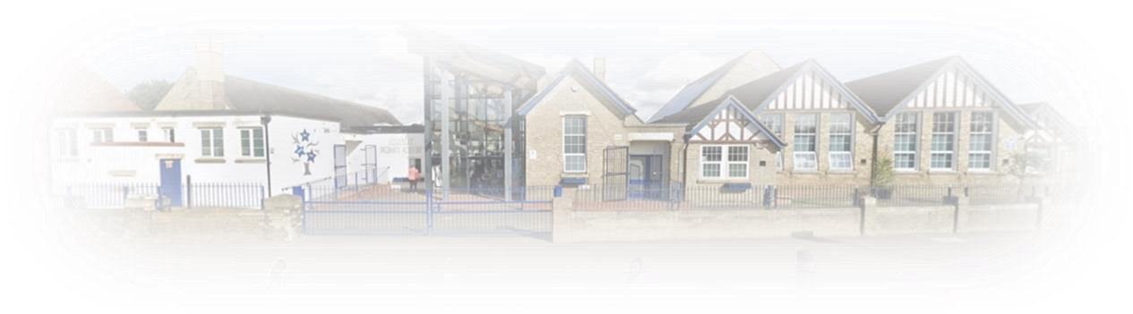






Summer brings lots of exciting opportunities and fun experiences, but we urge all parents to talk to their children about how to stay safe when they are out in the community and when they are online including what to do if they have a worry or something doesn’t feel right. We hope that everyone has a wonderful summer br eak – take good care and have a good rest if you can. We will look forward to seeing all the children, in Years 1 – 6, back in on Wednesday 3rd September.

Year 4 Ukulele Performance
Hits All the Right Notes!
This week, Year 4 showcased their hard work and musical talent in a wonderful ukulele performance for their parents and classmates. Performing three well-loved songs—Hold My Hand, Shotgun, and Mamma Mia—the children played with confidence, rhythm, and a real sense of fun. Their enthusiastic audience was full of smiles, and the applause said it all—brilliant job, Year 4!

This week the overall academy attendance was 85.92%. Well done to Invaders who achieved the highest at 97.43%!
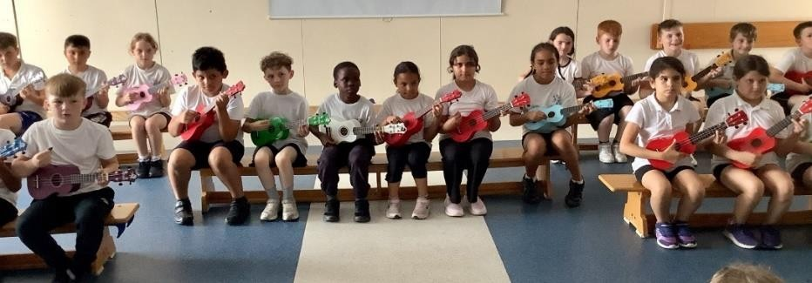
  Dates for Your Calendar
  Wednesday 23rd July – End of Term
  Wednesday 3rd September 2025 – Start of term.

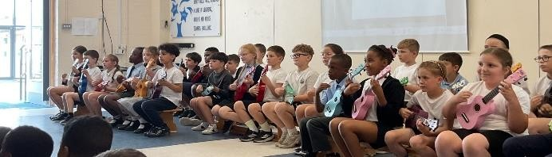
  Please see attached to this newsletter information about our brand new Gymnastics club which is starting in September! This is for KS2 children only. If you would like to enrol, please go to the link attached on the document.

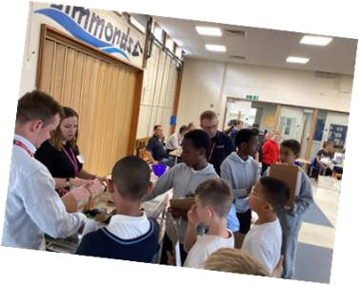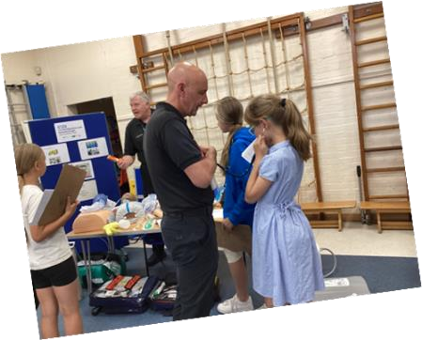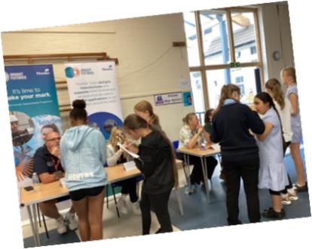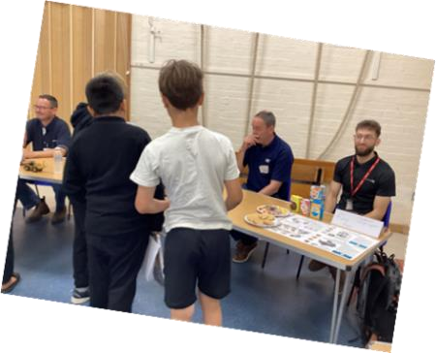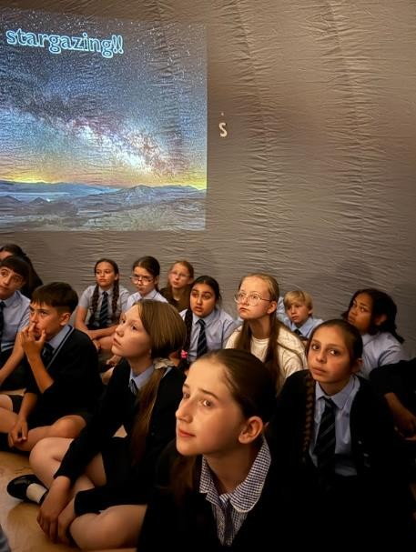

Discovery Primary Academy Yr 5/6
Careers Event

Wednesday 16th July 2025

On Wednesday 16th July the Year 5 and 6
pupils had the opportunity to talk to a range of
visitors from a variety of industries and
professions.

It was a successful morning, and we were lucky
enough to have over 20 visitors to talk to about
their jobs.

We would like to say a big thank you to the
following professions for coming to inspire the
pupils: the engineers from Perkins and Anglian
Water, an architect, an environmental health
officer, an interior designer, a graphic designer,
a beauty therapist, a

paramedic, a nurse,
school sports officer from Posh, apprentice
training co
-
ordinator and apprentice from
Howdens/Peter Brotherhoods, Army Officer,
Primary School teacher, and an education
advisor from Woburn Safari Park. The children
were able to ask th
em lots of questions, and
we hope it inspired them all for the future!

Year 5 & 6 Super Scientists

Year 5 and 6 were invited to Queen Katharine Academy to visit an
inflatable planetarium. Lucy from StarLincs taught the children all about
the planets, phases of the moon and different constellations. The children
had a fabulous time.

On Tuesday 15
^{th}

July, our budding scientists in Year 5 took part in the
Queen Katharine Academy Science Fair. The children worked really hard
over the last term to plan, carry out and report on an investigation of their
choosing, which they proudly displayed. The investi
gations included:

•

Metamorphosis of a jellyfish

•

How different liquids affect your teeth (using eggs)

•

Parachute making

•

Mentos in different liquids

•

Conductors and insulators in a circuit

•

Lemon volcanoes

•

How soap affects bacteria

A big well done to the Year 5s and thank you to the families who came
down to support.

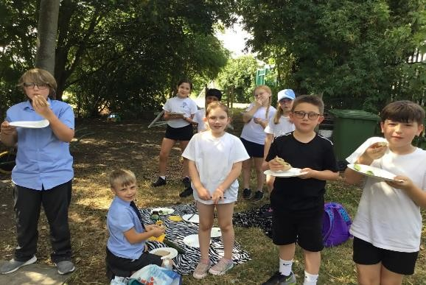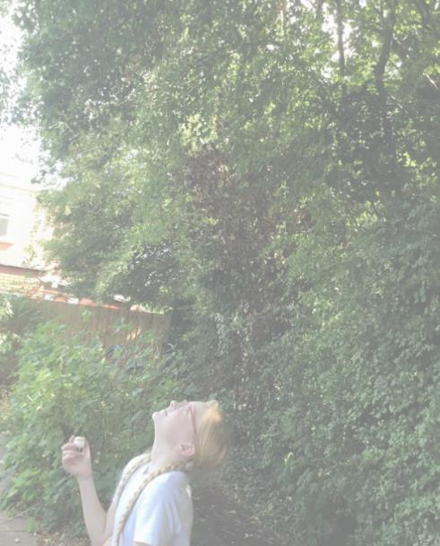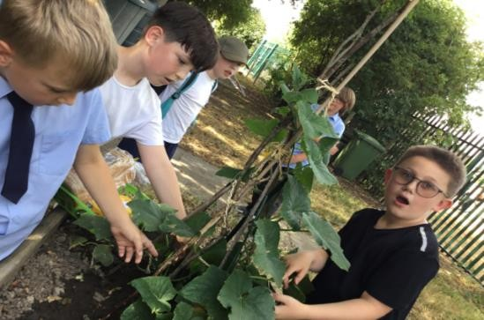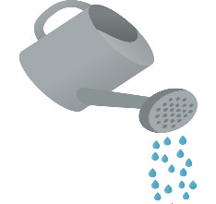
Thank you and well done to
the children for attending
gardening club this term.
We have had

some great
activities such as 30 days
wild week, planting growing
and eating cucumbers.
Please continue to work
with nature and happy
gardening over the summer.
Man
y thanks from Mrs Drew
Mrs Kennedy and Mrs
Morton.

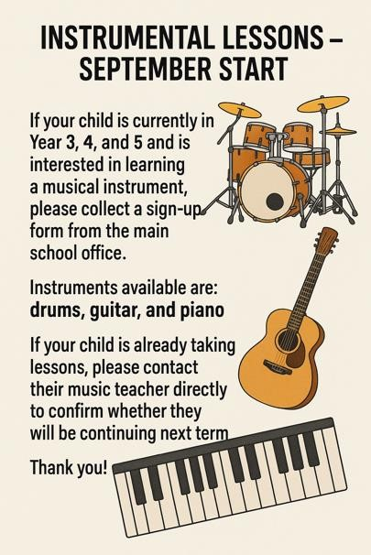


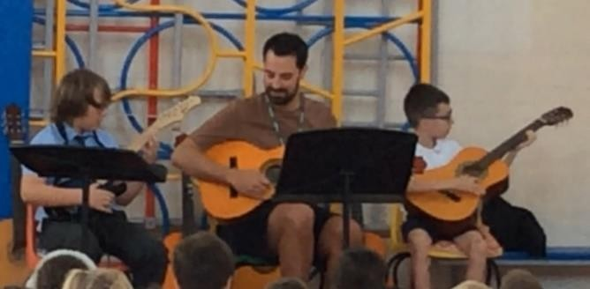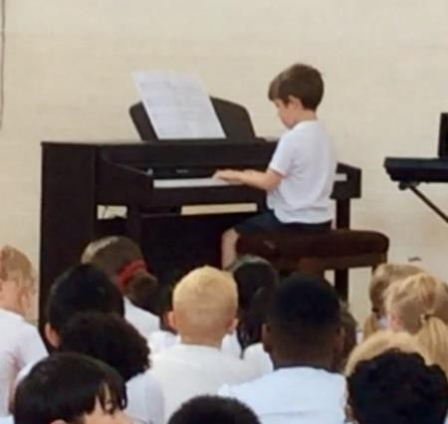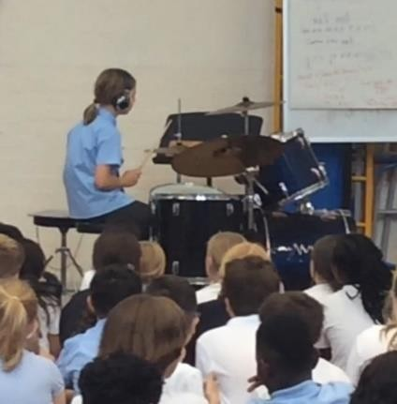

Celebrating Music Across the Academy
On Monday and Tuesday last week, children from across the academy came together to share their musical skills with parents, carers, and fellow pupils. It was a fantastic opportunity to celebrate all the hard work and progress they’ve made this year in their peripatetic music lessons.
Pupils performed on drums, guitar, and piano, showing just how much they’ve learned and how confident they’ve become. It was wonderful to see their enthusiasm and talent shining through.
We were delighted to welcome so many adults to support the children—it means a lot to them and helps make these musical moments even more special.

