
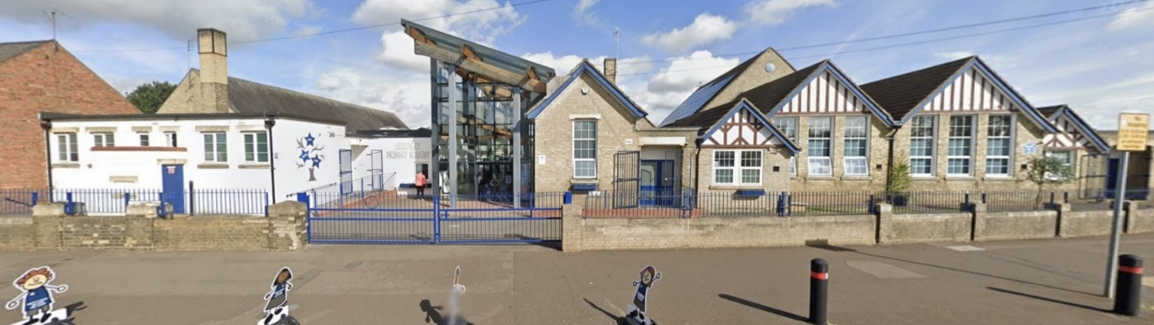
+
Discovery Primary Academy
Friday 12th September 2025

Dear Parent/Carer,
We warmly everyone back to Discovery!
The children have had a great start to the new year and they have enjoyed getting to know their new teachers and making new friends. The children should be very proud of their attitude to learning and all their hard work.
New Foundation Stage Children
Our new Foundation Stage children started full time this week and they are superstars! They have enjoyed playing outside on the trim trail and they have been practising their classroom routines. They have started phonemic awareness and have had a focus on listening this week. Well done to them all!
Topics
There is lots of exciting learning happening in Science across the academy. Year 1 are learning all about materials and they are testing them to discover their properties. Year 2 are finding out how to stay healthy and are learning about exercise and eating a balanced diet. Year 4 have been building circuits to light up bulbs and sound buzzers as part of their electricity topic. Year 5 have been investigating solids, liquids and gases and they have been separating and dissolving substances. Year 6 have started with a Geography topic about the UK and Norway and they have been identifying human and physical features.
Snacks
If you choose to send your child with a snack for break time, please ensure that this is a healthy snack, such as (but not limited to!): fruit, vegetable sticks, oat bars, or yoghurts.
Allergies
We have multiple children with nut allergies across the academy, so please avoid sending any food in with your child that contains nuts to keep all of our children safe. We have children with other allergies too. Sometimes parents like to send food in for their child’s class to enjoy, for example, as a birthday treat. If you would like to do this, please ensure that the food is in individual sealed packages, labelled with the ingredients. We are not able to share food with the children that has been cooked or baked at home.
Safety When Eating
We are also mindful that some foods may cause a choking hazard to children. We request that, either in snacks or packed lunches, grapes are cut lengthways into quarters and that no meat on the bone (such as chicken drumsticks) is sent in.

Attendance is important for every child at Discovery Primary Academy, and we understand sometimes it can be difficult to know if you should send your child in or not. Here is a quick guide based on the NHS guidelines.
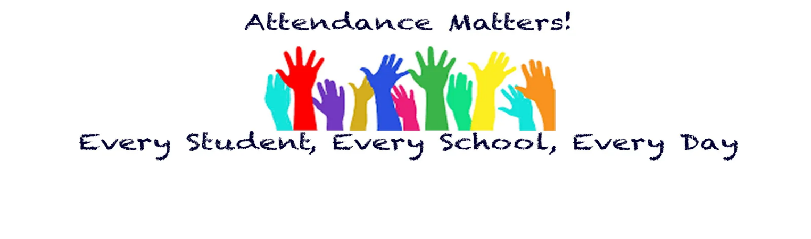

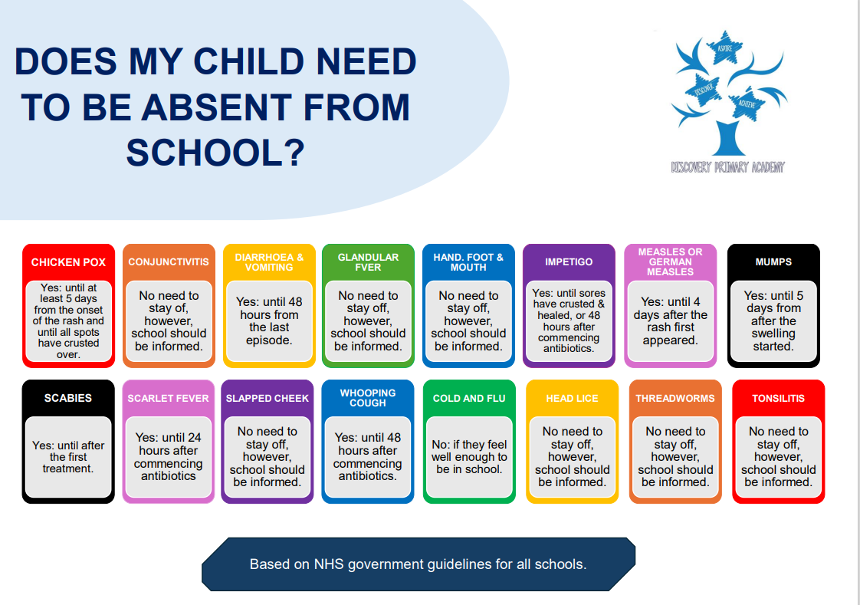
This week the overall academy attendance was 96.74%. Well done to Pyramids who achieved the highest at 99.51%!
Dates for Your Calendar
Wednesday 8th October – Pupils photos
Wednesday 22nd October 2025 –
Parents Evening 3:40pm – 6:10pm
Wednesday 22nd October 2025 –
Parents Evening 3:40pm – 6:10pm
Thursday 23rd October 2025 –
Parents Evening 3:40pm – 6:10pm
Friday 24th October 2025 - Last day of term
Monday 3rd November – First day back at school

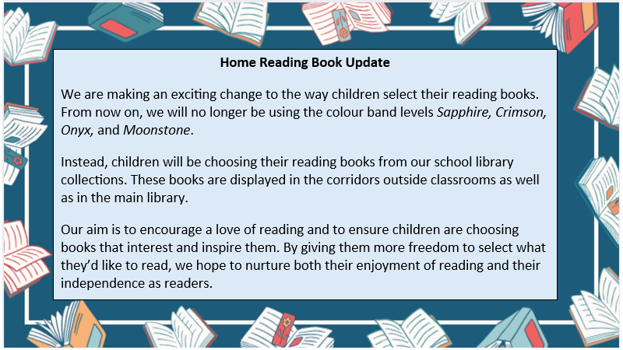

We are refreshing the way we keep you in the loop! Going forward, you'll receive a monthly newsletter filled with important updates, upcoming events, student highlights, and more. Next newsletter will be sent out in October.


