

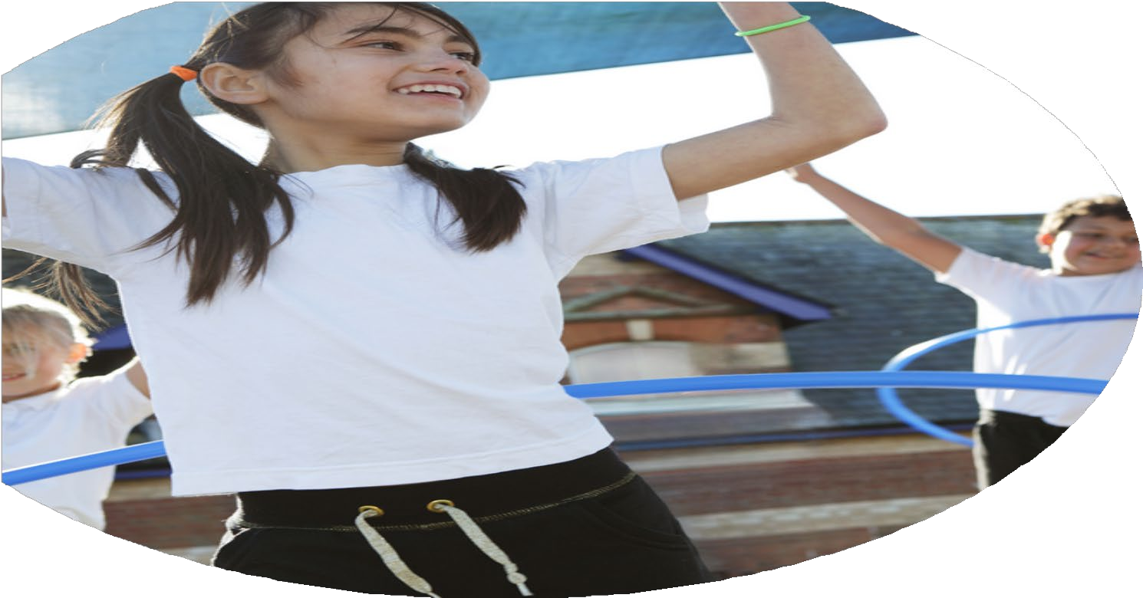
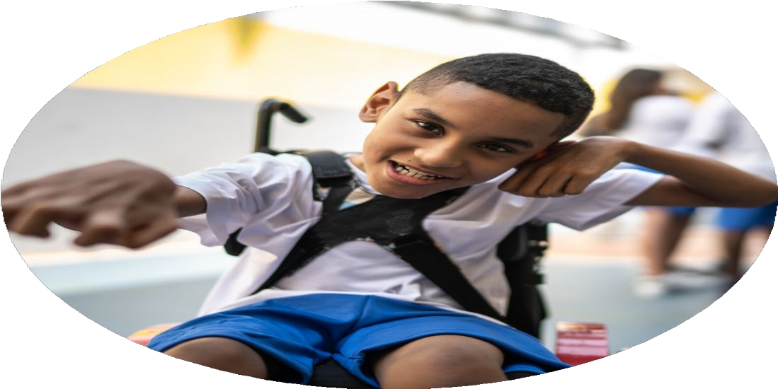




PE Funding
Evaluation Form

Commissioned by

Created by

Images courtesy of Youth Sport Trust

Review of last year 2023/24
We recommend that you start by reflecting on the impact of current provision and reviewing your previous spend
What went well?  - Teaching in PE and pupil engagement has been monitored to support the improvement of teaching PE.  - PE coaches delivered a comprehensive range of extra-curricular sports clubs, which included archery and golf in multi sports to broaden children’s experiences.  - The Academy took part in a wide range of Soke sporting events such as the SEND Games and MAT Games. We also participated in competitive events such as cross country and rounders.  - We held our own Y1/2 Multi-Sports event.  - Olympian Alice Sharpe visited the academy to run a HIIT circuit and lead assemblies for the children  - The academy has netball and girls and boys football teams, that have competed in local Peterborough leagues during the year.  - Year 6 Sports Leaders were appointed and ran multi-sports festivals in KS1 and helped with sports day for the whole academy.  - Because of our provision in sport and PE, we achieved the Gold School Games Mark. | How do you know?  Lesson drop ins were carried out to observe teaching. Children continued to be come dressed in kit to facilitate participation and those unable to participate still took part in the lessons with specified roles such as’ talent scout’  We had multi sports clubs across KS1 and KS2 in addition to netball and football clubs. External sports coaches from Peterborough United also ran football clubs after school. Clubs were well attended in each term.  Children from across the academy were able to go to sporting events, which were whole class festivals as well as competitive team events.  Y1 and Y2 attended their own festivals at school, run by Y6 play leaders.  Children from the whole academy had the opportunity to take part in the exercise circuit with Alice and be inspired by her when they met her in an assembly and heard her story.  Wearing team kits, our football and netball teams competed in various matches across the year. A real sense of excitement and pride was fostered by all teams.  Year 6 children embraced the opportunity to develop their own sports-based activities for the Y1 and Y2 children. They developed their modelling skills and mentoring skills as part of the process.  Working proactively with the local SGO, the academy was awarded the Gold School Games Mark as recognition of our provision. | What didn’t go well?  - Swimming took place in year 5 and top-up swimming in 6. The numbers of children who reached end of key stage expectations were low. This is a continued trend at the academy. Few of our children have the opportunity to swim, outside of the lessons arranged by the academy. | How do you know?  Only 31% of our children left the end of KS2, being able to competently swim using a range of strokes.

Intended actions for 2025/26 What are your plans for 2025/26? | How are you going to action and achieve these plans?
Intent  We will continue with our association with AMVC and remain part of the Soke Sports cluster. This will provide access to a wide range of sporting experiences for our children, both competitive and non-competitive. It also includes staff CPD.  We will continue to have football and netball teams, that will represent the academy at local competitions and participate in local school games leagues.  A team of year 5 and year 6 children will be trained as playleaders, and will be responsible for leading purposeful and active play and lunchtime playtimes.  The academy will be having a ‘pop-up’ swimming pool installed on site to enable our children to competently learn to swim. The year 6 top up swimming will be more extensive than in any previous years. As a result of the pool being on site, children will swim daily. | Implementation  A service level agreement has been signed. The events calendar has been released and reviewed at the first Soke Sports PE leaders meeting.  Extra-curricular clubs will be run by sports coaches to facilitate this.  Plans for a range of activities will be planned and equipment purchased to support children during unstructured playtimes, further encouraging a physically active environment.  Fiesta swimming will install and maintain an on-site indoor swimming pool during the spring term and provide swimming lessons.

What impact/intended impact/sustainability are you expecting?  Enabling our children to experience a range of sporting experiences, including competitive sport will help them to develop healthy lifestyles, a love of physical activity, resilience and interpersonal skills. All these skills are vital for them to be well rounded individuals when they leave the academy.  By giving year 5 and year 6 children the roles of playleaders this will develop their leadership qualities, while supporting their peers and younger children on the playground. With more purposeful play taking place, issues with behaviour should be reduced. Upper KS2 children who also find these unstructured times difficult can have a playleader role to focus them and develop their coping strategies too.  All children leaving year 6 will be able to swim 25m competently, using a range of strokes and be able to safely self rescue. | How will you know? What evidence do you have or expect to have?  Children will be engaged in all aspects of their academy life. Through the use of pupil and teacher voice surveys, children’s resilience and attitudes to learning will be monitored.  The playleaders will work co-operatively in the play zones, leading their activities. Children will have the opportunity to try different games and activities at playtime. Issues with behaviour will be minimised. Children will return to classes after playtime with positive attitudes and be ready for learning. Evidence will be collected through pupil and teacher voice surveys.  At the end of the top-up swimming sessions, children will be assessed by a qualified swimming instructor.

Actual impact/sustainability and supporting
What impact/sustainability have you seen?  Association with AMVC  Children have accessed a wide range of sporting experiences that have included both competitive and non-competitive opportunities. As an academy we have also engaged with the School Games Organiser and have supplemented these opportunities to participate in additional festivals and tournaments. There have also been specific opportunities for children with SEND to take part in. Children readily participate in physical activity as part of their academy day.  Football and Netball Teams  The PE teaching team have run boys’ football, girls’ football and netball clubs throughout the year. As a result of this, the academy has entered a football team into the School Games mixed and girls football leagues. The netball team also entered the netball league.  Purposeful Play  The academy has invested in a range of play equipment to support active and purposeful play at lunchtime. A team of Playleaders have been recruited and trained to cover a timetable of activities across playtime for both KS1 and KS2. Being a Playleader is a leadership role in school for the children, they wear badges and also create and run multi-skills festivals for year 1, 2 and 4.  Swimming Provision  A ‘pop-up’ swimming pool was installed on site during the spring term at the academy. The year 6 children had extensive top-up swimming lessons from qualified swimming coaches. Their swimming skills were assessed to have improved significantly during the sessions that they took part in, giving them water safety and swimming skills for life. | What evidence do you have?  Children have been excited to attend the events throughout the year and have fully participated in all activities that they have been given the opportunity to take part in. As an academy, we are continuing to develop our whole school physical literacy approach and have further promoted physical activity to create enjoyable experiences through initiatives such as Monster Kickabout, National School Sports Week and National Skipping Week. Pupil Voice has been used to monitor engagement in PE and the wider curriculum, giving pupils a voice to express themselves.  All teams played in all their league matches. Both football teams came second in their leagues; the girls played their final match at the Peterborough United Weston Homes Stadium. The academy netball team reached the county finals, playing their match in Cambridge.  The playleaders follow their duty rota each day and liaise with staff about any issues with equipment, swapping duties to cover absence, ensuring that activities continue to run. The children show high levels of maturity and have developed their social and teamwork skills. Staff on duty have reported that lunchtime playtimes have been transformed by the changes and there are a reduced number of behaviour incidents as a result of the children being engaged in purposeful, active play.  At the start of year 6 top-up swimming:  5% of children were able to swim at least 25m.  5% of children were able to use a range of strokes effectively.  7% of children were able to perform safe self-rescue in different water-based situations.  At the end of year 6 top-up swimming:  57% of children were able to swim at least 25m.  61% of children were able to use a range of strokes effectively.  63% of children were able to perform safe self-rescue in different water-based situations.

