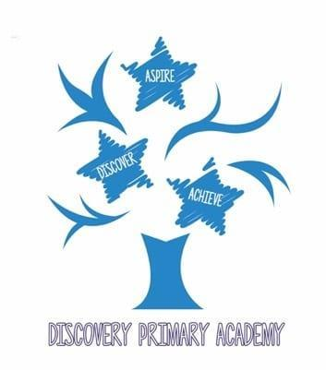
Discovery Primary Academy Music Curriculum 2026/27
National Curriculum objectives
KS1
- Pupils should be taught to listen with concentration and understanding to a range of high-quality live and recorded music
KS2
- Pupils should be taught to listen with attention to detail and recall sounds with increasing aural memory.
- Pupils should be taught to appreciate and understand a wide range of high-quality live and recorded music drawn from different traditions and from great composers and musicians.
- Pupils should be taught to develop an understanding of the history of music.

Progression in Music by Strand
Listening, Reflecting and Appraising
Autumn Spring Summer

Year Group | Objectives
Reception | Listen to sounds and respond by talking about them or through movement and dance.  Recognise, identify and name percussion instruments used in the classroom.  Begin to identify and describe key features or strong contrasts within a piece of music.  Begin to use musical terms such as louder/quieter, faster/slower and higher/lower.  Participate in appropriate peer feedback.
Year 1 | Listen to a piece of music and move in time to its steady beat.  Recognise and respond through movement to different musical characteristics and moods.  Recognise, identify and name instruments used in the classroom.  Use musical terms such as louder/quieter, faster/slower and higher/lower.  Begin to explain how changes in tempo, pitch and dynamics affect the mood of music.
Year 2 | Listen with increasing concentration to contrasting music from a range of styles.  Recognise percussion instruments, name them, describe how they are played and identify which can produce high and low sounds.  Recognise how sounds are produced, including tapping, rattling, scraping and blowing.  Identify different qualities of sound such as smooth, scratchy, clicking and ringing (timbre).  Recognise and respond to changes in tempo, dynamics and pitch.  Respond through movement or dance to different musical characteristics and moods.  Recognise the mood of a piece and begin to explain how musical choices create that mood using appropriate terminology.
Year 3  Samba  Whole class instrumental tuition | Identify, where appropriate, a steady beat and specific rhythm patterns.  Identify common musical characteristics within contrasting pieces.  Recognise aurally wooden, metal and skin percussion instruments and name them with increasing accuracy.  Listen with concentration to longer pieces or extracts from contrasting musical styles.  Listen to live and recorded examples from different kinds of music.  Recognise familiar instrumental sounds in recorded music, including piano, violin, guitar and drums.  Identify repetition in music.  Describe tempo, dynamics and melody using appropriate musical terminology.
Year 4  Ukulele  Whole class instrumental tuition | Listen to, recognise and discuss contrasting musical styles using appropriate language, including tempo, dynamics, metre, texture and timbre.  Identify repeated rhythmic or melodic phrases in live and recorded music.  Identify verse/chorus and call-and-response structures.  Identify the use of metre in live or recorded music.  Recognise and discuss the combined effect of layers of sound in arrangements, compositions and recordings.  Participate in appropriate peer feedback.
Year 5  Recorder  Whole class instrumental tuition | Listen to, recognise and discuss contrasting musical styles using appropriate musical language, including tempo, dynamics, metre, texture and timbre.  Distinguish differences in timbre and texture across a wide variety of instruments and combinations of instruments.  Use musical vocabulary to identify areas for development or refinement when composing and performing.  Give and respond to constructive peer feedback.  Identify and discuss what happens within simple musical structures.
Year 6  ICT  Whole class instrumental tuition  Djembe  Whole class instrumental tuition | Listen to, recognise and compare contrasting musical styles, independently applying knowledge of the interrelated dimensions of music.  Analyse and explain differences in timbre and texture across a wide range of instruments and combinations of instruments.  Identify and explain how musical structures develop and change over time.  Use musical vocabulary to discuss music from a variety of sources, traditions and cultures, including their own and others' performances and compositions.  Use musical vocabulary and knowledge to justify suggestions for development and refinement when composing or performing.  Give constructive peer feedback and use feedback to refine musical outcomes.

Edited and amended from the Minimum expected standards 2012 (London borough of Barking and Dagenham) by Donna Barnes.

