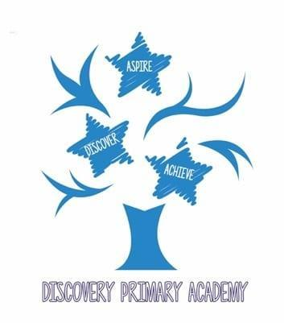
Discovery Primary Academy Music Curriculum 2026/27
National Curriculum objectives
KS1
- Pupils should be taught to experiment with, create, select and combine sounds using the inter-related dimensions of music.
KS2
- Pupils should develop an understanding of musical composition, organising and manipulating ideas within musical structures and reproducing sounds from aural memory.
- Pupils should be taught to improvise and compose music for a range of purposes using the inter-related dimensions of music

Progression in Music by Strand
Exploring Musical Ideas
Autumn Spring Summer

Year Group | Objectives
Reception | Improvise freely using voice, body sounds, found objects and classroom instruments.  Explore different sounds made by the voice, hands, found objects and conventional instruments (timbre).  Explore high and low sounds (pitch).  Explore long and short sounds (duration).  Explore loud and quiet sounds (dynamics).  Explore fast and slow sounds (tempo).  Begin to explore how different sounds can convey mood or meaning.  Respond to musical ideas through movement.  Collaborate with others when exploring and creating sounds.
Year 1 | Improvise simple vocal, body-percussion or instrumental responses.  Explore and vary loud and quiet sounds (dynamics).  Explore and vary fast and slow sounds (tempo).  Explore and vary high and low sounds (pitch).  Explore and vary long and short sounds (duration).  Explore contrasting timbres using the voice, hands and classroom instruments.
Year 2 | Improvise short musical ideas in response to a stimulus.  Explore how sounds are made and changed by tapping, blowing, scraping and shaking.  Explore long and short sounds within rhythmic patterns.  Explore changes in pitch, including higher and lower sounds.  Create and develop short repeated rhythmic patterns.  Respond to musical ideas through movement.  Collaborate with others to explore and develop musical ideas.  Create sounds in response to a visual or aural stimulus.  Manipulate sounds to convey different effects and moods.  Organise explored sounds into simple sequences and structures.
Year 3  Samba  Whole class instrumental tuition | Improvise rhythmic and melodic ideas using voice, body percussion and instruments.  Explore changes in duration, tempo, pitch and dynamics using tuned and untuned percussion and voices.  Explore and compare the timbres of different instruments.  Explore the range of timbres that can be produced by a single instrument.  Collaborate with others to develop and perform musical ideas.  Use movement to respond to and develop musical ideas.  Explore and create ideas using body percussion.  Use symbols, graphic scores and simple traditional notation to capture explored ideas.
Year 4  Ukulele  Whole class instrumental tuition | Improvise and develop musical ideas using the ukulele, voice and classroom instruments.  Explore and use chord patterns as a basis for musical ideas.  Use movement to explore pulse, rhythm and musical character.  Explore the expressive use of silence and rests.  Experiment with texture by layering contrasting sounds.  Develop musical ideas using body percussion.  Explore how musical choices can describe feelings, moods or images.  Collaborate with others to select, develop and refine musical ideas.
Year 5  Recorders  Whole class instrumental tuition | Improvise and develop rhythmic or melodic ideas using recorder, voice and classroom instruments.  Explore how timbre can influence the character and intention of a composition.  Use conventional and graphic notation to capture and develop musical ideas.  Experiment with texture by combining and layering musical parts.  Collaborate with others to develop, rehearse and refine musical ideas.  Use music technology to explore, record and manipulate sounds for a musical purpose.
Year 6  ICT  Whole class instrumental tuition  Djembe  Whole class instrumental tuition | Use music technology to explore, record, manipulate and develop musical ideas for a clear purpose.  Create and develop texture by layering rhythmic and/or melodic ostinati.  Improvise with repetition, sequence and melody, selecting ideas to develop further.  Use movement to explore and communicate rhythmic or expressive musical ideas.  Develop ideas using musical devices including call and response, repetition and ostinato.  Explore and apply characteristics of varied musical styles.  Improvise with increasing confidence and independence.  Use body percussion to create, combine and develop rhythmic ideas.  Collaborate effectively, making and explaining choices when developing musical ideas.

Edited and amended from the Minimum expected standards 2012 (London borough of Barking and Dagenham) by Donna Barnes.

