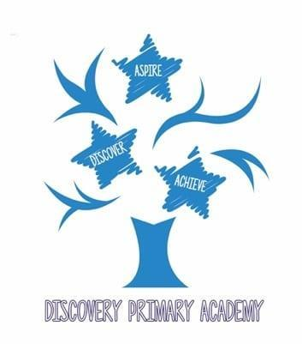

Discovery Primary Academy Music Curriculum 2026/27
National Curriculum objectives
KS1
- Pupils should be taught to use their voices expressively and creatively by singing songs and speaking chants and rhymes.
KS2
- Pupils should sing and play musically with increasing confidence and control.
- Pupils should be taught to play and perform in solo and ensemble contexts, using their voices and playing musical instruments with increasing accuracy, fluency, control and expression.

Progression in Music by Strand
Singing
Autumn Spring Summer
Year  group | Objectives
Reception | Understand the importance of warming up the voice.  Speak and chant short phrases together.  Find their singing voice and begin to develop awareness of pitch over a small range of notes.  Make changes in their voices to express different moods and feelings.  Coordinate actions with a song.  Sing short phrases or responses independently.  Sing a variety of songs, both accompanied and unaccompanied.
Year 1 | Understand the importance of warming up and begin to demonstrate good posture, breath control and diction to support vocal health.  Sing and chant together.  Sing in time to a steady beat.  Coordinate actions with a song.  Sing songs with increasing vocal control, including improved pitch accuracy, breathing and clear diction.  Perform an action or body-percussion sound on the steady beat while singing.  Sing songs in different styles, conveying contrasting moods with enjoyment and expression.
Year 2 | Understand the importance of warming up and demonstrate good posture, breath control and diction to support vocal health.  Perform and understand call and response.  Sing a variety of songs with increasing pitch accuracy.  Develop singing confidence through a range of styles.  Sing words clearly and breathe at appropriate phrase endings.  Convey the mood and meaning of a song.  Echo-sing short melodic phrases.  Identify whether pitch is getting higher, lower or staying the same, and copy this with the voice.  Follow a leader, starting and stopping together.  Sing or chant in two parts.  Begin to show awareness of phrasing and dynamics.  Sing with increasing control of dynamics and tempo.
Year 3  Samba  Whole class instrumental tuition | Show increasing accuracy of pitch and awareness of the shape of a melody.  Imitate increasingly longer phrases with accuracy.  Sing songs with a recognised structure, including verse/chorus and call and response.  Understand the importance of warming up and demonstrate good posture, breath control and diction.  Develop awareness of vocal health.  Sing songs in a variety of styles with confidence, performing an increasing number from memory.  Develop singing confidence through varied styles.  Copy and recall short melodic phrases.  Perform in a group or as a soloist with increasing musical awareness, expression and phrasing.  Show awareness of phrase structure within a song.  Chant or sing a round in two parts with increasing confidence, accuracy and balance.
Year 4  Ukulele  Whole class instrumental tuition | Sing confidently as part of a small group or as a soloist, with good posture and clear diction.  Understand the importance of warming up.  Develop awareness of vocal health.  Sing songs in a variety of styles with increasing awareness of vocal tone and melodic shape.  Sing with musical expression, using phrasing, changes of tempo and dynamics to reflect the mood and character of a song.  Sing rounds with increasing confidence and pitch accuracy.  Develop singing confidence through varied styles.  Rehearse and refine a performance, developing stagecraft.
Year 5  Recorders  Whole class instrumental tuition | Sing confidently in a wide variety of styles with expression.  Communicate the meaning and mood of a song.  Apply good posture, breath control and diction following an appropriate vocal warm-up.  Demonstrate awareness of vocal health.  Sing confidently both independently and within a group.  Show awareness of phrasing, melody, dynamics and structure.  Rehearse and refine a performance, developing stagecraft.
Year 6  ICT  Whole class instrumental tuition  Djembe  Whole class instrumental tuition | Independently apply good posture, breath control and diction following an appropriate vocal warm-up.  Demonstrate secure awareness of vocal health.  Perform a song or rap from memory with attention to phrasing, dynamics and pitch accuracy.  Sing confidently and expressively in a wide variety of styles, adapting the voice appropriately.  Communicate and interpret the meaning and mood of a song.  Rehearse, refine and present a performance with increasing independence and confident stagecraft.

Edited and amended from the Minimum expected standards 2012 (London borough of Barking and Dagenham) by Donna Barnes.

