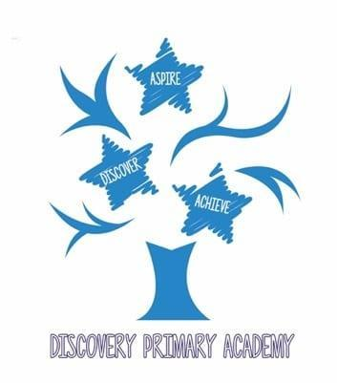
Discovery Primary Academy Music Curriculum 2026/27
National Curriculum objectives
KS1
- Pupils should be taught to play tuned and untuned instruments musically
KS2
- Pupils should sing and play musically with increasing confidence and control.
- Pupils should develop an understanding of musical composition, organising and manipulating ideas within musical structures and reproducing sounds from aural memory.
- Pupils should be taught to play and perform in solo and ensemble contexts, using their voices and playing musical instruments with increasing accuracy, fluency, control and expression.
- Pupils should be taught to use and understand staff notation.

Progression in Music by Strand
Using Instruments
Autumn Spring Summer

Year Group | Objective
Reception | Start and stop together.  Begin to develop a sense of beat using instruments or body sounds.  Respond to symbols or hand signs.  Play loudly, quietly, fast and slow.  Copy a simple rhythm pattern or a number of beats played on an instrument.  Play along to music, showing developing awareness of the beat.  Explore instruments by shaking, scraping, rattling and tapping.  Play with a sense of purpose and enjoyment.
Year 1 | Play instruments using a range of actions, including shaking, scraping, rattling and tapping.  Play in time to a steady beat using instruments or body sounds.  Play loudly, quietly, fast and slow.  Imitate a rhythm pattern on an instrument.  Play a repeated rhythmic pattern (rhythmic ostinato) to accompany a song.  Play a single pitched note to accompany a song.  Follow simple hand signals for loud/quiet and start/stop.
Year 2 | Play with increasing control while maintaining a steady beat.  Perform a repeated two-note melodic ostinato to accompany a song.  Perform a rhythmic accompaniment to a song.  Play getting faster or slower and getting louder or quieter.  Follow a leader, starting and stopping together.  Perform with increasing confidence as part of a group and individually.  Perform a sequence of sounds using a graphic score.  Work and perform in smaller groups.
Year 3  Samba  Whole class instrumental tuition | Keep a steady beat on an instrument, in a group or individually.  Follow simple hand directions from a leader.  Perform with awareness of others.  Perform a composed piece to a friendly audience as part of a group or class.  Maintain a rhythmic pattern or steady beat.  Use tuned percussion with increasing confidence.  Copy a short melodic phrase by ear on a pitched instrument.  Play from symbols, including graphic and/or simple traditional notation.  Maintain a melodic ostinato simultaneously with a contrasting ostinato.
Year 4  Ukulele  Whole class instrumental tuition | Read and play from conventional music symbols and chord charts.  Combine instrumental playing with movement.  Follow a leader, responding to start/stop, faster/slower and louder/quieter directions.  Use instruments with increasing confidence to accompany songs.  Play music in a metre of four.  Perform confidently to an audience of peers and adults.
Year 5  Recorder  Whole class instrumental tuition | Continue to develop control on tuned and untuned instruments.  Maintain a rhythmic or melodic accompaniment to a song.  Read and play with confidence from conventional notation or chord charts.  Identify and apply features of an effective performance.  Perform confidently to peers and adult audiences.  Perform own compositions to an audience.  Perform with sensitivity to changes in dynamics and tempo.
Year 6  ICT  Whole class instrumental tuition  Djembe  Whole class instrumental tuition | Perform own compositions confidently to an audience.  Use music technology to compose, record and review performances.  Play tuned and untuned instruments with increasing fluency, extending the length and complexity of phrases and melodies.  Perform with sensitivity and control in response to dynamics and tempo.  Read and perform with increasing independence from conventional or graphic notation.  Evaluate and refine performances, explaining what contributes to an effective musical outcome.

Edited and amended from the Minimum expected standards 2012 (London borough of Barking and Dagenham) by Donna Barnes.

