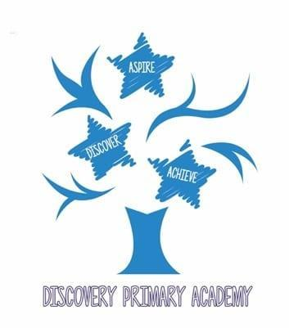
Discovery Primary Music Curriculum 2026/27
National Curriculum objectives
KS1
- Pupils should be taught to experiment with, create, select and combine sounds using the inter-related dimensions of music
KS2
- Pupils should develop an understanding of musical composition, organising and manipulating ideas within musical structures and reproducing sounds from aural memory.
- Pupils should be taught to use and understand staff notation
- Pupils should be taught to improvise and compose music for a range of purposes using the inter-related dimensions of music

Progression in Music by Strand
Composing and Arranging
Autumn Spring Summer
Year Group | Objectives
Reception | Begin to create and manipulate different effects on a sound source or instrument.  Add chosen sound effects at an appropriate moment in a story or song.  Sort and name different sounds.  Create a sequence of different sounds in response to a given stimulus.
Year 1 | Add sound effects to a story.  Choose musical sound effects to follow a storyline or match a picture.  Sequence symbols to create a simple structure or score.  Compose and perform an independent sequence of sounds.
Year 2 | Create short repeated rhythmic patterns (ostinati).  Create short melodic phrases.  Create rhythm patterns from words.  Create a piece of music with a clear beginning, middle and end.  Create and use graphic-score notation.
Year 3  Samba  Whole class instrumental tuition | Create a simple rhythmic accompaniment to a song using ostinato patterns.  Compose music with a recognisable structure, such as beginning/middle/end or verse/chorus.  Use repetition and echo within compositions.  Create and perform from a graphic or symbol score.  Create words and actions to accompany songs.
Year 4  Ukulele  Whole class instrumental tuition | Create a simple melody from a selected group of notes and use simple chord patterns, including a three-chord ostinato.  Compose music with a recognisable structure.  Use notation to capture and communicate compositions.  Write lyrics to fit a musical idea or structure.
Year 5  Recorder  Whole class instrumental tuition | Create sound sequences that reflect the meaning of words or a given stimulus.  Compose music that reflects a clear intention.  Compose using a recognised musical structure.  Refine compositions following discussion and feedback.  Arrange a song for class performance.  Use a range of conventional, chord and graphic symbols to record compositions.  Use music technology to record, sample, sequence, loop and manipulate sounds within compositions.
Year 6  ICT  Whole class instrumental tuition  Djembe  Whole class instrumental tuition | Select and use appropriate conventional or graphic notation to record and communicate compositions.  Use music technology independently to record, sample, sequence, loop and manipulate sounds for a clear musical purpose.  Compose music that reflects a clear intention, selecting and combining ideas such as descriptive music, call and response and ostinato accompaniment.  Create and develop original songs or raps in which the music reflects the meaning and character of the lyrics.  Arrange a song for class performance, selecting an appropriate percussive accompaniment.  Review, refine and improve compositions in response to feedback, explaining musical choices.

Edited and amended from the Minimum expected standards 2012 (London borough of Barking and Dagenham) by Donna Barnes.

